**Assignment 3**

|  |  |
| --- | --- |
| Date | 15 October 2022 |
| Team ID | PNT2022TMID52670 |
| Project Name | Personal Expense Tracker |
| Maximum Marks | 2 Marks |

1.Create a Bucket in IBM object storage.

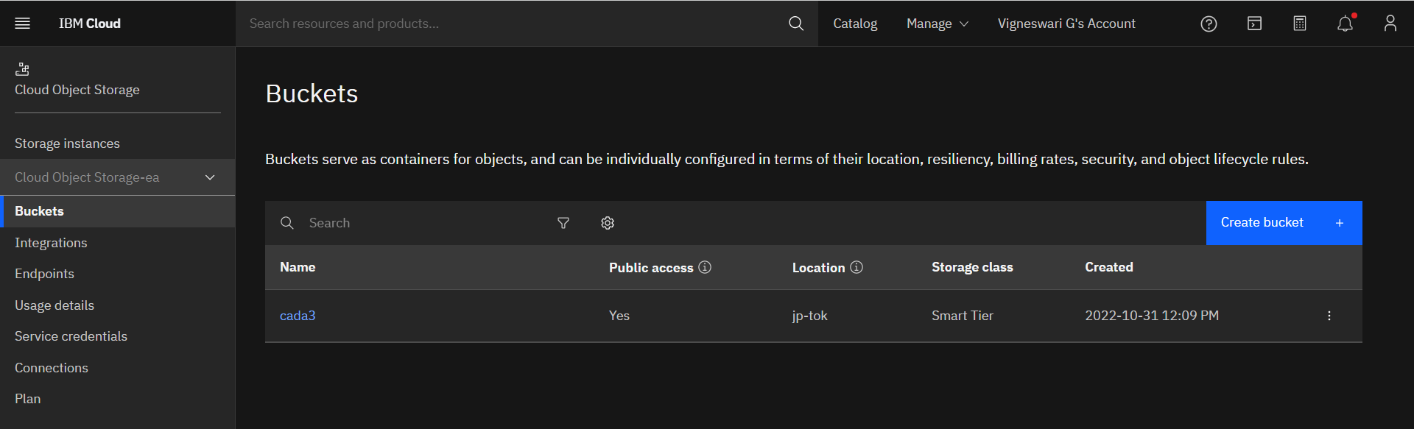

2. Upload any 5 images to IBM object storage and make it public. Write HTML code to displaying all the 5 images.

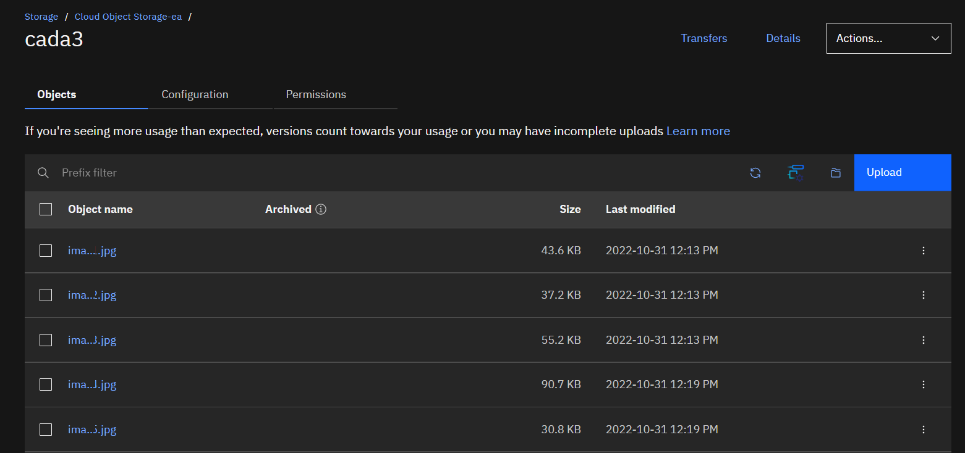

**HTML Code:**

**<!DOCTYPE** *html***>**

<html *lang*="en">

<head>

    <meta *charset*="UTF-8">

    <meta *http-equiv*="X-UA-Compatible" *content*="IE=edge">

    <meta *name*="viewport" *content*="width=device-width, initial-scale=1.0">

    <title>Nature</title>

</head>

<body>

    <h2 *style*="color:red">Most Beautiful Places to Explore...</h2>

    <img *src*="https://cada3.s3.jp-tok.cloud-object-storage.appdomain.cloud/image-2.jpg" *alt*="image-2" *width*="20%" *height*="20%">

    <img *src*="https://cada3.s3.jp-tok.cloud-object-storage.appdomain.cloud/image-3.jpg" *alt*="image-3" *width*="20%" *height*="20%"><br>

    <img *src*="https://cada3.s3.jp-tok.cloud-object-storage.appdomain.cloud/image-1.jpg" *alt*="image-1" *width*="20%" *height*="20%">

    <img *src*="https://cada3.s3.jp-tok.cloud-object-storage.appdomain.cloud/image-4.jpg" *alt*="image-4" *width*="20%" *height*="20%"><br>

    <img *src*="https://cada3.s3.jp-tok.cloud-object-storage.appdomain.cloud/image-5.jpg" *alt*="image-5" *width*="20%" *height*="20%">

</body>

</html>

**OUTPUT:**



3. Upload a CSS page to the object storage and use the same page in your HTML code.

**HTML Code:**

**<!DOCTYPE** *html***>**

<html *lang*="en">

<head>

    <meta *charset*="UTF-8">

    <meta *http-equiv*="X-UA-Compatible" *content*="IE=edge">

    <meta *name*="viewport" *content*="width=device-width, initial-scale=1.0">

    <link *rel*="stylesheet" *href*="https://cada3.s3.jp-tok.cloud-object-storage.appdomain.cloud/styles.css">

    <title>Nature</title>

</head>

<body>

    <h2 >Most Beautiful Places to Explore...</h2>

    <img *src*="https://cada3.s3.jp-tok.cloud-object-storage.appdomain.cloud/image-2.jpg" *alt*="image-2">

    <img *src*="https://cada3.s3.jp-tok.cloud-object-storage.appdomain.cloud/image-3.jpg" *alt*="image-3"><br>

    <img *src*="https://cada3.s3.jp-tok.cloud-object-storage.appdomain.cloud/image-1.jpg" *alt*="image-1">

    <img *src*="https://cada3.s3.jp-tok.cloud-object-storage.appdomain.cloud/image-4.jpg" *alt*="image-4"><br>

    <img *src*="https://cada3.s3.jp-tok.cloud-object-storage.appdomain.cloud/image-5.jpg" *alt*="image-5">

</body>

</html>

CSS File uploaded:

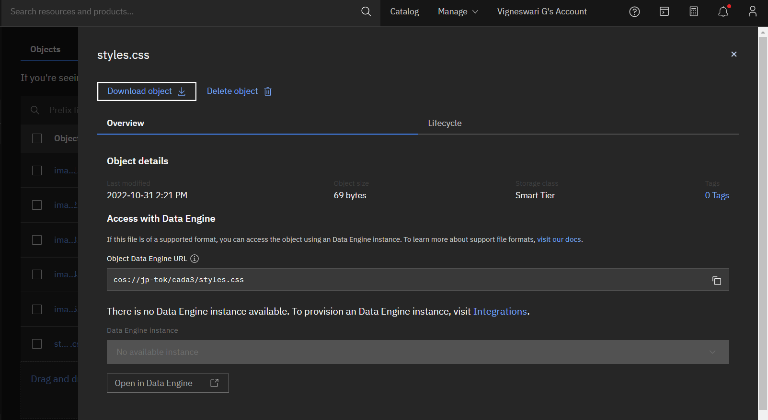

4. Design a chatbot using IBM Watson assistant for hospital. Ex: User comes with query to know the branches for that hospital in your city. Submit the web URL of that chat bot as an assignment.

Web URL of chat box:

<https://web-chat.global.assistant.watson.appdomain.cloud/preview.html?backgroundImageURL=https%3A%2F%2Fus-south.assistant.watson.cloud.ibm.com%2Fpublic%2Fimages%2Fupx-ca1cfc0c-9550-4f88-bd8c-f5f1cd2ce705%3A%3A1985c074-45c0-4933-8413-ca16cc58d403&integrationID=1b30ea5f-e84e-4ea1-92b4-c73b68b91e30&region=us-south&serviceInstanceID=ca1cfc0c-9550-4f88-bd8c-f5f1cd2ce705>

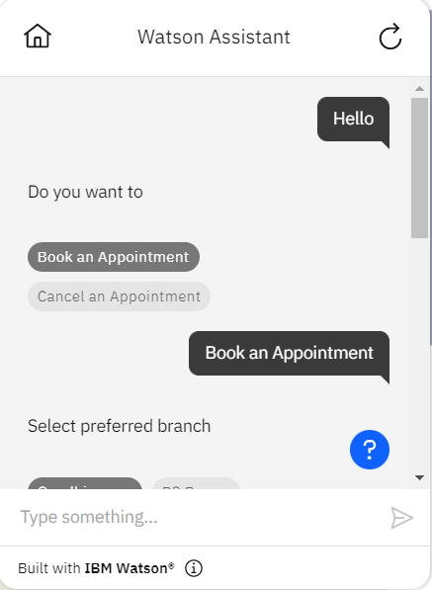

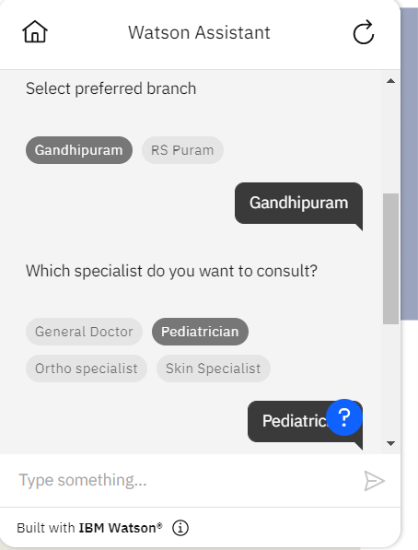

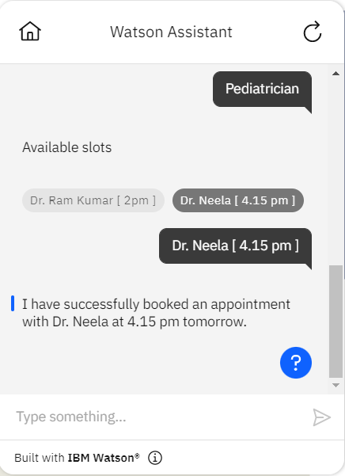

5. Create Watson assistant service with 10 steps and use 3 conditions in it. Load that script in HTML page.

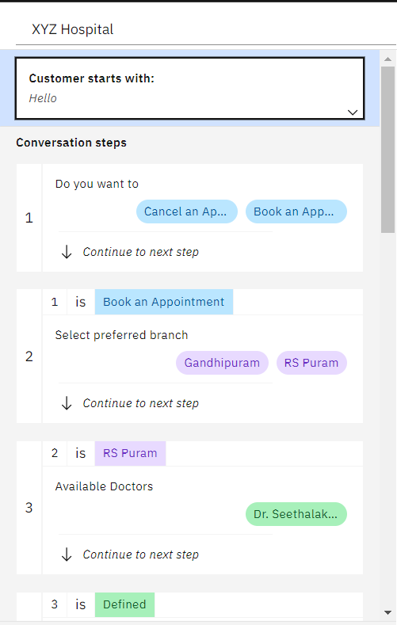

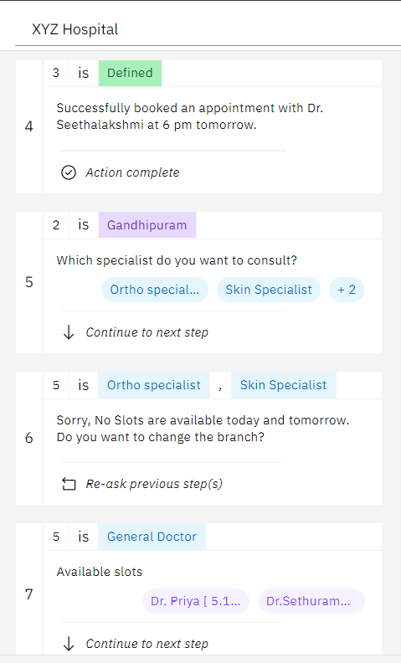

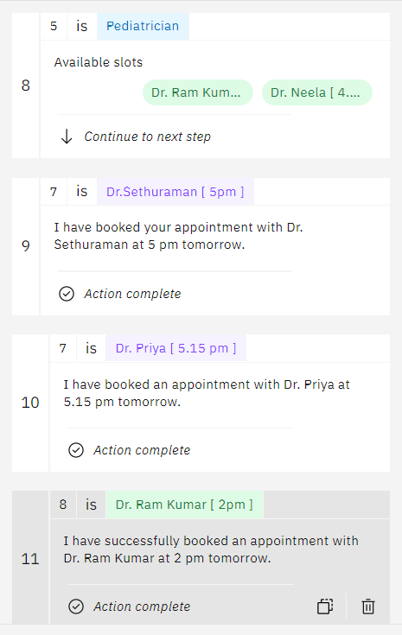

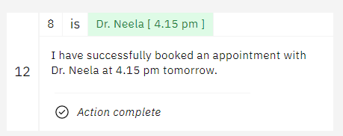

5. Create Watson assistant service with 10 steps and use 3 conditions in it. Load that script in HTML page.

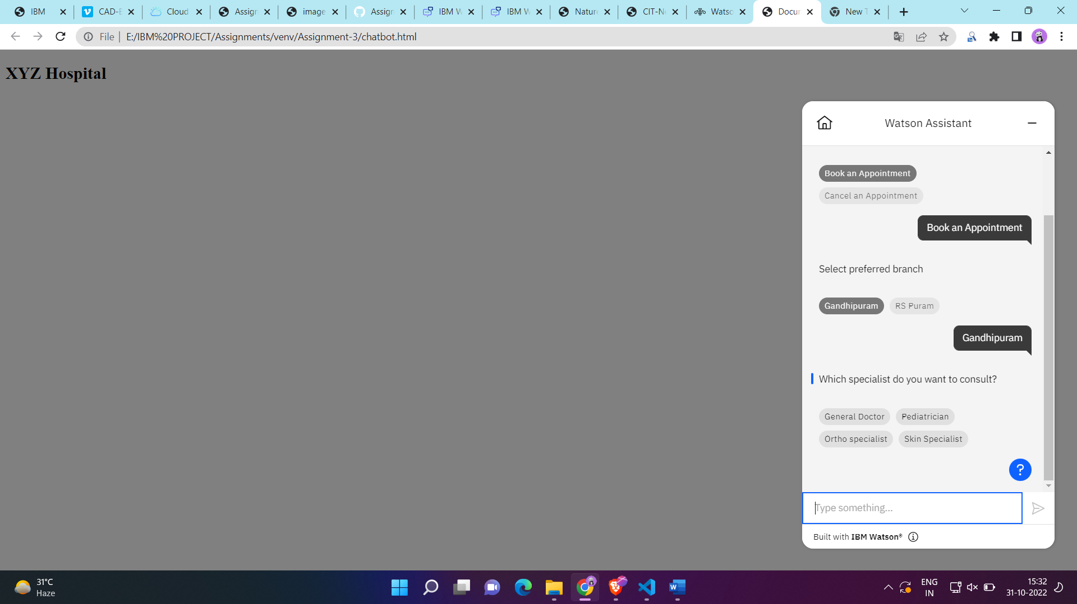

**HTML CODE:**

**<!DOCTYPE** *html***>**

<html *lang*="en">

<head>

    <meta *charset*="UTF-8">

    <meta *http-equiv*="X-UA-Compatible" *content*="IE=edge">

    <meta *name*="viewport" *content*="width=device-width, initial-scale=1.0">

    <script>

        window.watsonAssistantChatOptions = {

          integrationID: "1b30ea5f-e84e-4ea1-92b4-c73b68b91e30", *// The ID of this integration.*

          region: "us-south", *// The region your integration is hosted in.*

          serviceInstanceID: "ca1cfc0c-9550-4f88-bd8c-f5f1cd2ce705", *// The ID of your service instance.*

*onLoad*: *function*(instance) { instance.*render*(); }

        };

*setTimeout*(*function*(){

*const* t=document.*createElement*('script');

          t.src="https://web-chat.global.assistant.watson.appdomain.cloud/versions/" + (window.watsonAssistantChatOptions.clientVersion || 'latest') + "/WatsonAssistantChatEntry.js";

          document.head.*appendChild*(t);

        });

      </script>

    <title>Document</title>

</head>

<body *style*="background-color: grey;">

    <h2>XYZ Hospital</h2>

    <a *href*="https://web-chat.global.assistant.watson.appdomain.cloud/preview.html?backgroundImageURL=https%3A%2F%2Fus-south.assistant.watson.cloud.ibm.com%2Fpublic%2Fimages%2Fupx-ca1cfc0c-9550-4f88-bd8c-f5f1cd2ce705%3A%3A1985c074-45c0-4933-8413-ca16cc58d403&integrationID=1b30ea5f-e84e-4ea1-92b4-c73b68b91e30&region=us-south&serviceInstanceID=ca1cfc0c-9550-4f88-bd8c-f5f1cd2ce705"></a>

</body>

</html>